Laboratory Activity: Scanning for General Vulnerabilities

# Data File

Conducting Security Assessments\MBSASetup-x64-EN.msi

# Before You Begin

You will be using Microsoft Baseline Security Analyzer (MBSA), a vulnerability scanning tool.

# Scenario

At Company, periodic vulnerability scans will enable you to see what vulnerabilities lie in your network, and also keep track of any changes that have been made to your systems. Detecting a change in vulnerabilities over time will keep you up-to-date and informed about your servers' security needs. So, you'll use the MBSA to conduct a preliminary scan of your Windows VirtualBox.

1. Install the MBSA.
   1. In File Folder, from the course data files, double-click the **MBSASetup-x64-EN.msi** file.
   2. In the **Open File - Security Warning** dialog box, select **Run**.
   3. In the **MBSA Setup**wizard, select **Next**.
   4. On the **License Agreement** page, select **Iaccept the license agreement** and select **Next**.
   5. On the **Destination Folder** page, select **Next** to accept the default folder.
   6. On the **Start Installation** page, select **Install**.
   7. In the **MBSA Setup** message box, select **OK**.
2. Use the MBSA to scan your system to establish baseline security values.
   1. On the desktop, double-click the **Microsoft Baseline Security Analyzer 2.3** shortcut to open it.

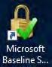

* 1. In the **Microsoft Baseline Security Analyzer 2.3** window, in the **Check computers for common security misconfigurations** section, select the **Scan a computer** link.



* 1. Verifythat yourcomputernameappears in the **Computername**drop-downlist, and uncheckthe **Check for SQL administrative vulnerabilities** check box.

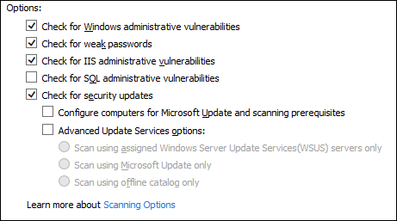

* 1. Select **Start Scan**.



**Note:** This scan will take 5 to 10 minutes to complete.

1. Review the scan results.
   1. When the scan completes, examine the list of results.
   2. For any of the results listed, select a **Whatwasscanned** link to open a browser window with more information about how MBSA scans a particular component of the system. When finished examining this information, close the browser window.
   3. For any of the results listed, select a **Howtocorrectthis**link to open a browser window with more information on potential fixes for system vulnerabilities. When finished examining this information, close the browser window.

# What vulnerabilities did MBSA detect in its scan?

1. **How can a vulnerability scan like this help ensure the security of your systems?**
2. Close the **Microsoft Baseline Security Analyzer 2.3** window.

# Instructions:

1. Answer questions 4 and 5.
2. Document this process/output through screenshots and provide brief description of it.